CS 255 System Design Document Template

This template lays out all the different sections that you need to complete for Project Two. Each section has guidance to prompt your thinking. You will need to continually reference the interview transcript as you work to make sure that you are addressing your client’s needs. There is no required length for the final document. Instead the goal is to complete each section based on what your client’s needs are. Remove this note when you are finished, and replace all bracketed text with the relevant information.

UML Diagrams

UML Use Case Diagram
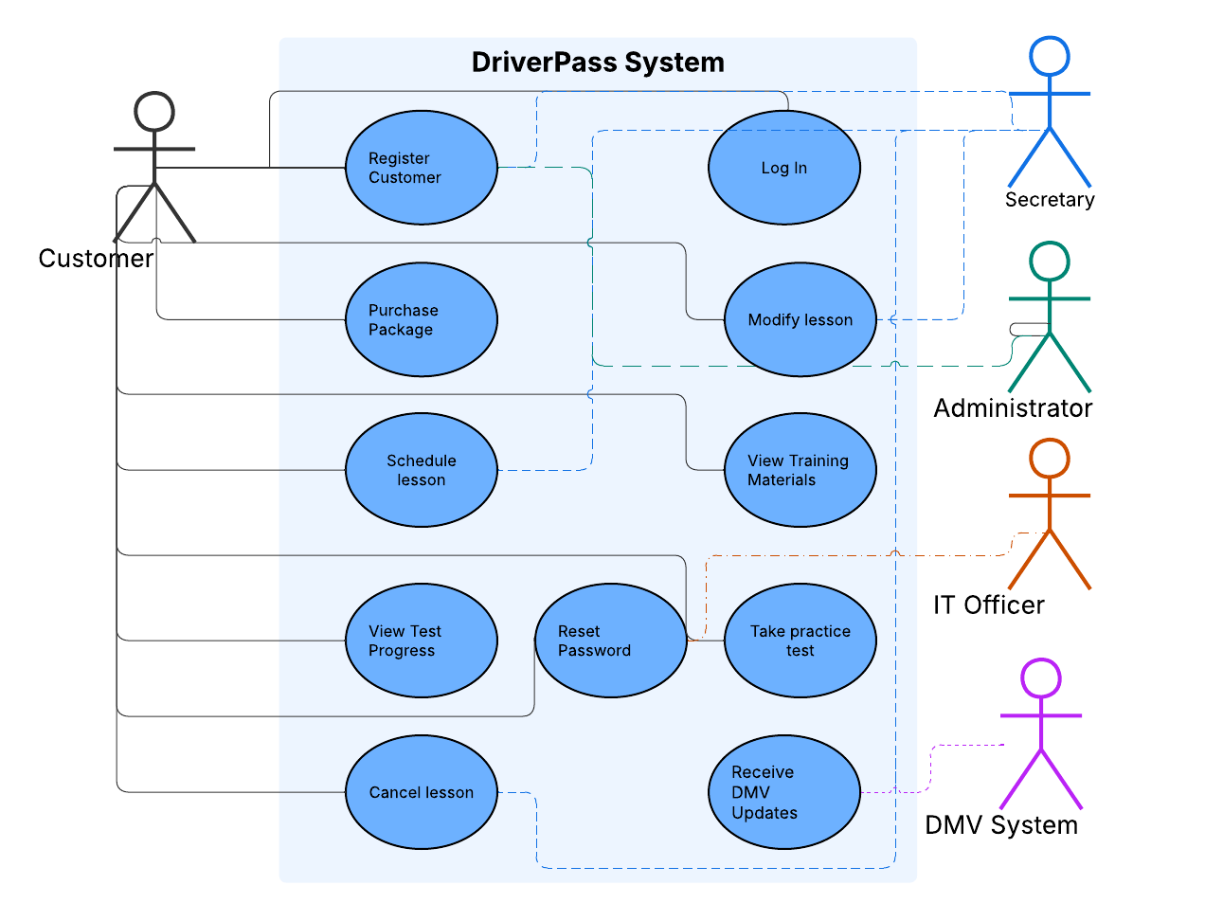

UML Activity Diagrams

UML Sequence Diagram
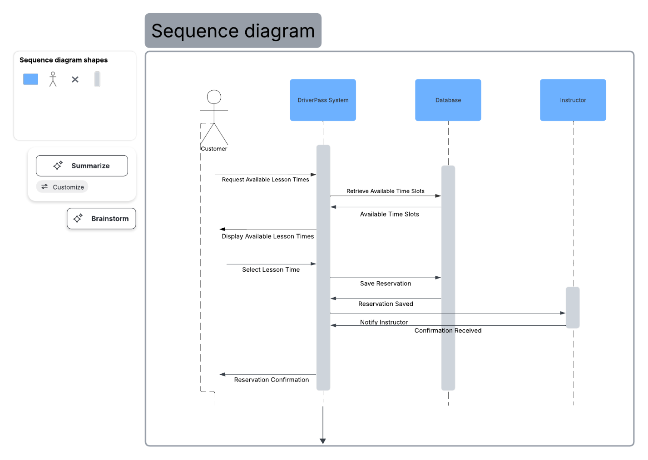

UML Class Diagram
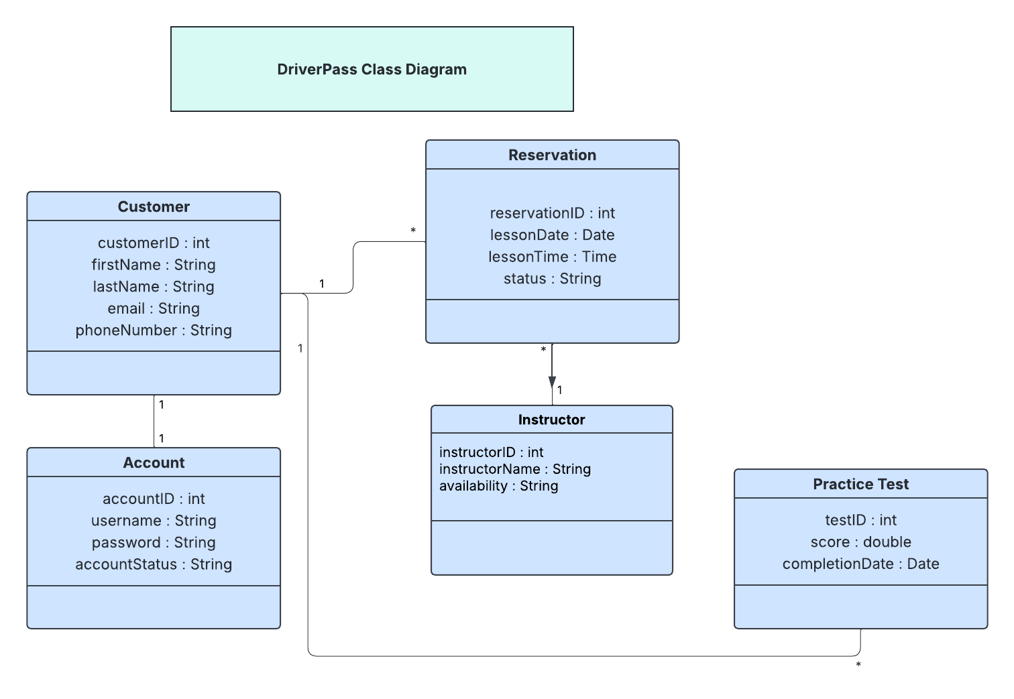

Technical Requirements
The DriverPass system will require computers and smartphones so customers can access the system and schedule lessons. Employees and instructors will also need devices to manage accounts and reservations. A secure server will be needed to store customer and lesson information.

The system will run through web browsers such as Google Chrome or Microsoft Edge. A database management system will be used to store customer accounts, reservations, and practice test results. Security features such as password protection will help keep user information safe.

The infrastructure for DriverPass will require a reliable internet connection and cloud-based storage. These technical requirements will allow customers to create accounts, schedule lessons, and take practice tests while giving employees access to the information they need to manage the system.

